Creating Subscriptions

1. Go to <http://mstr.rogers.com/microstrategy/asp/Main.aspx>
2. If you are already logged in with your LAN ID, logout.
3. Login using Administrator credentials.

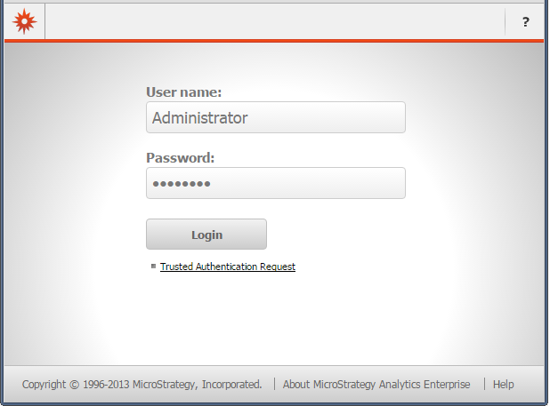

1. Open the project
2. Navigate and hover above the report that needs to be scheduled and click on Subscriptions

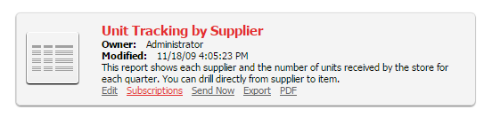

1. From the following list of Subscriptions select the type of subscription requested by the user

* Personal View
* History List
* Mobile
* Email
* File
* Print

**Email Subscription**

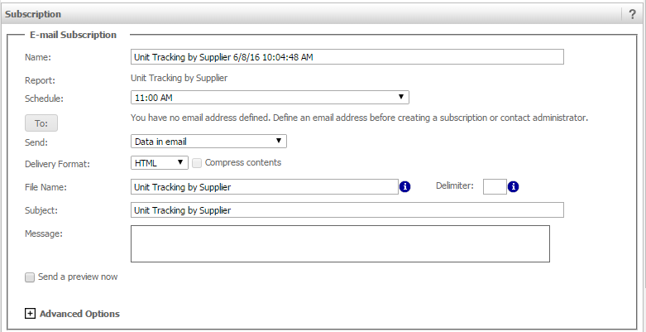

Fill up the subscription details and select a schedule when the report has to be delivered.

Click on “To” button to select the recipients.

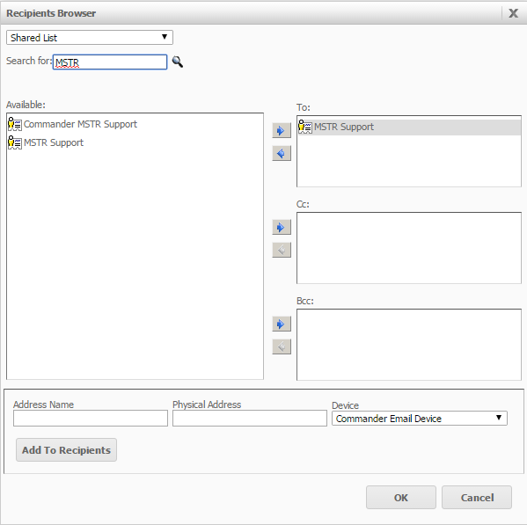

*Add **MSTR Support** as a recipient to every subscription.

Modifying Subscriptions

1. Go to <http://mstr.rogers.com/microstrategy/asp/Main.aspx>
2. If you are already logged in with your LAN ID, logout.
3. Login using Administrator credentials.



1. Open the project
2. Go to My Subscriptions

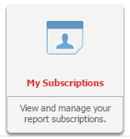

1. From the list of subscription select and edit the subscription that you would like to modify.